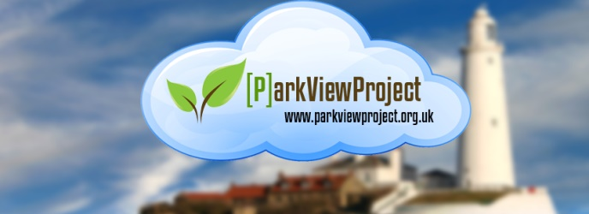
Park View Project (“Getting you Online to Offline Community Activities”)
Annual Round Up 2021
Mission:
To raise awareness and reach out to those in North Tyneside who are not on the radar of many socially essential services because they are digitally excluded. This applies to all who consider themselves vulnerable, regardless of age or ability, and who have to confront the challenges of adapting to a digital world or suffer the consequences of becoming digitally and, potentially, socially excluded.
Aims & Objectives: Park View Project will:
1. Enable beneficiaries to manage their own lives more easily and more effectively, and to pursue their own goals and aspirations via an online presence.
2. Enable users to identify with and support each other both online & offline.(Peer mentoring)
3. Promote personal development goals by increasing confidence, motivation, self-esteem and skills via our online Community Reporter Learning Programme' and peer support mentoring program.
4. Promote community involvement by developing community-based initiatives that catalyse the sharing of information and the broadcasting of new informal community support via offline activities across the borough.
5. Provide opportunities for volunteering including Online Chum Mentoring Service involvement..
6. Support our volunteers by facilitating personal development portfolios that represent experience and competencies achieved throughout their time with the project.
7. Enable individuals to share personal experiences arising from cyber-crime and how to protect themselves using our community e-toolkit (Ongoing development).
8. Address Digital Poverty by enabling access to social media or other digital products via access to support from our Online Chums Mentoring service, including research into affordable digital products and connectivity.
9. Educate about aspects of freely available Assistive Technology and its use.
10. Digital First Aid using online ‘Learn My Way’ course – Good Things Foundation - and ‘My Computer My Way (Ability.Net) incorporating basic digital skills and modifications to digital items to make them easier to use.
11. Access to online Health & Social Care support via NHS Library of Apps and other online help locally and nationally.
12. Support the development of work/life skills using online financial skills training.
Our services are not exclusively for disabled or elderly people but include help for young adults who have experienced cyber-crime, bullying, trolling, etc., Ex-servicemen experiencing a disconnect because of lack of skills, confidence, resources, financial aid, employment, Further Education, migrants/refugees looking for help in searching for local and national resources and traveller communities.
The context: North East England has the highest percentage of limited users 53% compared to other English regions with only 18% classified as extensive users (Ofcom 2020). This illustrates that Digital Exclusion is a complex matter. For example, with no or few qualifications many use the internet but for only for social media and entertainment, with many only using smart phones which affects critical engagement – Many have digital skills for life but not for work. For older and disabled adults the picture is different with cultural and physical barriers creating Digital Exclusion that often goes under the radar of socially essential services.
Why Park View Project came into being:
Society is experiencing a digital transition where many day to-day tasks require having access to the internet. This is creating a negative impact on older and disabled residents who are at risk of becoming ‘dependent’ because they are unable to assert being ‘in control’. For example, Lack of skills, access to local resources, privacy, affordability, social isolation and cyber-crime, are some of the issues raised by those on the digital periphery Furthermore, we must confront difficult to resolve cultural & social barriers that discourage people from using the internet: For older people, it is resistance to change, perceived lower levels of educational ability, it’s too complicated and there is nobody to help me, etc., Whereas younger disabled children and adults, it is online abuse, lack of Assistive Technology, communication difficulties, language and cyber-crime that limits their online presence. Our services, therefore, need to be flexible in approach and innovative in developing new ways of supporting people.
To address these issues, we have identified a volunteer role called Volunteer Online Chum Mentor who acts as a digital befriender providing mentoring support to enable and empower older, disabled people, including those who are unemployed or who have experienced Cyber-crime, to take control over internet products and their online presence. For instance, many older and unemployed people face enormous challenges since the digitization of benefit claims have now been introduced by the DWP. They have no personal access to a PC having to use public libraries, which are not best suited to saving confidential data; not having to hand details required for completing benefit claims; personal settings cannot be assured, confidentiality and time-limited booking of PC's, etc., and more recently, the closure of local libraries and job centres; loss of informal information hubs such as Post Offices and newsagents have compound the problem. A similar set of circumstances exist with increasing numbers of socially essential services moving to online only access. These local pressures can cause social and economic disruption and, in many cases, lead to a community disconnect, such as penalties levied on those who do not comply with job seeking requirements regarding proof of job searches or losing out on Government financial support they are entitled to.
Social goals: Our online presence is not just about providing a safe and secure space for people to get on-line, it is also a tool for creating community connections that can be harvested in such a way as to create real opportunities for members to form relationships both online and offline; to aide in this we have introduced a fun-based learning module based on simple stages of journalism where members can share community activities, stories, articles and features. This becomes an integral part in the enabling process where skills learnt empower and create a community stake towards helping others get on-line.
Our online platforms are built using social capital, incorporating community engagement practices, where ownership is shared, where governance is not exclusive but inclusive and where diversity is embraced and in step with the ‘Government’s Digital Inclusion Strategy’. (Web address: - https://www.gov.uk/government/publications/government-digital-inclusion-strategy) – we are mindful that access to digital technology is not used as an alternative to traditional community interaction, but is used to promote ‘real community involvement’. While ‘Humanizing the Web’ we want to encourage individuals to bridge the digital divide and get involved in the number of ‘digital Fireside Groups’, where people can share interests and trade information in real space & time and, importantly, increase their social circles of support.
Organisation status:
Park View Project was established on January 4th 2013 as a community & voluntary association. As a group, we felt that there was insufficient reason to register as a formal charity. However, we are now considering the benefits attached to registering with the Charity Commissioners. The main motivation has been restricted access to funding streams, with many requiring you are a registered charity or other recognised status and development of strategic planning incorporating the forming of community partnerships. This has meant Park View project has been constrained in what types of trusts it can approach. However, this has not stopped halted us from delivering a range of services, or creating informal partnerships where beneficiaries and organisations mutually benefit in delivering support.
Our services:
The Digital Divide: This is aimed at individuals living in North Tyneside who lack confidence, skills or don’t have access to internet to broaden their personal horizons. Our Online Chums support individuals to access local essential services, regardless of their ability and, facilitate effective access to e-services with a view to increasing local community participation via a ‘Fireside Group’ approach to participation. Online Chums represent a diverse background of skills and experience, and who may be unemployed, retired or disabled themselves.
Our ‘Community Reporters’ program is designed to encourage individuals to research a story, article or feature about aspects of their local community that they edit and then upload to web platformd. Our Online Chums can provide support to individuals tackling this learning module, if requested, and can accompany individuals on assignments. Based on Citizen Journalism the learning model is a mix of offline and online encounters with the community where the learner embraces personal development goals alongside learning basic digital skills.
Our digital presence continues to differentiate itself from other charity-based digital support by promoting ‘real’ social interaction rather than act solely as a ‘digital tutor’. The advantages are: we can confront the barriers that older, disabled, and other disenfranchised individuals experience, and together find solutions to break down social and affordability barriers to getting online and, critically, reconnecting with the local community. .
Funding: (2014-2016)
The project was financially kick-started in September 2014 following Awards 4 All grant consisting of 10,000. This expired on 31st August 2015, although surplus funding derived from externally generated income allowed an extension covering September and October of that year regarding two sessional workers. In June 2015 we were awarded 5,773.00 from the European Social Fund, which was restricted to spending by end of July 2015. This permitted additional resources from our Training Facilitator to be allocated to group training. We were also awarded 800.00 from the Police Commissioners Fund to roll out e-resources around Community Safety, which assisted in increasing awareness of the community website. We received generated income of 1,300 from a local charity who invested in our social media training course for their clients, many who have a Learning Disability. By the 31st August 2015 we had a small reserve to help with continuity of core services.
Funding: (2016 – 2017)
Applications for support from Children in Need £8,392.00 and Heritage Lottery £8,700.00 enabled us to launch Children in Need Information Rangers training programme and a Heritage Lottery Grant to develop a WW1 – A Disability perspective - a theme focusing on survivors and how their experience socially and economically impacted on local communities. Our role was to provide digital support in both sharing data collected and archiving. We also received funding from The Joicey trust £450.00 towards increasing opportunities for those unemployed, on a low income or who, lack of digital skills, to participate as Information Rangers enabling them to access local resources to help find work; Funding from Comic Relief Community Cash Fund, (£800.00) towards creating health-based community activities in the form of Tia Chi aimed at older and disabled members of the community, that had originated from involvement in our community website and embryonic beginnings of a ‘Digi-Café’. In September 2016 we also gained funding from Awards for All to develop an ‘Older Persons’ Digital Project (£905.45).
Funding (2018 – 2020)
Funding from Awards for All (Big Lottery) of 8,780 supported the development of our new volunteer role: Online Chum Mentor. This project was completed in September 2019. We submitted a further bid for 2020 based on development of internet connection project, which will focus on integrating physical activity i.e., carpet bowls, cinema club, and other social enterprise ideas, set up and managed by young people with a Learning Disability using a strong digital theme.
Funding (2020 – 2021)
2020 begun with two funding awards with £1,000 from R W Mann Trust and a further £1,000 from Ballinger Trust. We also received funding from The Children’s Fund of £996.00. This will help us reach out to individuals linked to our partner network by providing hands on digital learning with a further £856.00 to Celebrate National Lottery 25 years. We received help from local organisations such as Karbon Homes and Newcastle Round Table who have responded to the national emergency (Covid19) with resources to reach out to those experiencing digital poverty. Good Things Foundation with the help of a donation from Future Now received five Lenovo M7 Mini Tablets providing a lifeline for those with a disability who have no presence online. Further support was made possible from National Community Lottery to cover costs of additional training to volunteer Online Chum Mentors covering six months and most recently a donation from the Catherine Cookson Trust to support Covid19 restrictions during closure of our drop in services. We have recently received support from Thomas Wall Trust and the Rothley Trust to test early stage piloting of Assistive Technology interventions that will inform our Digital First Aid future plans.
Activities and events: (2014 – 2016)
Organised a Community Safety Drop-in, arranged over a 4-week period, with the aim of raising awareness of issues around safety in the home, in the neighbourhood including internet safety focused on ‘surfing’ the web for information. In conjunction with this event Park View registered with Safer Internet Day. This event included representation from Northumbria Police Hate Crime Unit and the community Fire Service. Park View Project was invited to participate in a local project Expo, organised by North Tyneside Leisure & Learning. This was held at Whitley Bay Customer First Centre. This provided a networking opportunity with many small local groups and individuals about access to games that help digital skills and, importantly, increase social circles of support, and finally, we organised a workshop where we invited projects to participate in finding out about available Assistive Technology that is readily available on Microsoft platforms. This event was held at our partner’s premises - North Tyneside Disability Forum.
Activities and events: (2016 – 2019)
Following success in attracting new funding, this has enabled us to increase awareness across North Tyneside voluntary & community of the need for a more proactive approach to identifying a variety of support for specific groups who have not had an opportunity to increase their presence in which to promote and share digital learning resources. Information Rangers training programme was originally conceived in 2014 but has now been re-vamped to better reflect the needs of children and young people and their aspirations regarding the digital world. Park View project organised an event at Whitley Bay library on 26th January 2016 to show-case both the Heritage Lottery and Children in Need projects. This was well attended and proved invaluable in strengthening community support towards our aims & objectives. Further community development initiatives have provided opportunities for increasing our informal partnerships with other organisations with discussions taking place with Willington Quay Community partnership, who are keen to develop a ‘Digi-Training’ as a drop-in service. This will benefit Park View’s work by supporting borough-wide digital access, showcasing our Online Chum Mentoring scheme and our new Community Reporters skills building program.
Activities and events: (2020 – 2021)
We have registered as an Online Centres Network, which is a UK wide programme linking similar projects together to form a cooperative approach to reaching out to those on the digital periphery. This registration has opened up online training programs such as Learn My Way and Make it Click – Digital Basic skills courses, and our most recent plans towards creating a Digital First Aid Hub, which is currently being developed (Link to current draft . ..\Digital First aid 2019\Proposal Digital First Aid 2021.docx (Steve Forster, Digital Consultant 2019)
Management committee:
Mrs Ann Craven (Member Fireside Group)
Mrs Vicki Peacock (Chair)
Mrs Sue Adams
Mr Martin Lee
Mr Simon Schofield
Mr Martin Gooding
Mr Steve Forster Digital Consultant – Health & Social Care.
Volunteers are:
Mart Lee (Online Tutor for young people with LD)
Vicki Peacock (Online Chum) (Chair of Park View Project)
Sue Nicholson (WW1 Project)
Pauline O’Brien (WW1 Project)
Simon Schofield (Digital Champion)
Rose Roberts (Online Chum) (Website Development Group)
Colin Gray (Website Development Group
Robbie Dixon (Online Chum)
Lynne Hoult (Website Development Group)
Thomas Allison Online Chum Mentor.
Allen Brookes (Remote website support)
(This list does not reflect micro volunteering done as either one-off or as occasional returns).

Sessional Workers:
Previously Mathew Hall was our training and support worker. This post is now vacant. (Bob currently filling in where necessary with support from Vicki Peacock Park View Project’s chairperson) Subsequent involvement of sessional staff has been key in progressing our community-based projects.
Dr Bob Dennis (Community development)
Bob is responsible for managing day-to day activities of Park View Project with support from a sessional facilitator made possible from finance from the European Social Fund award. Following expiry of this fund the Facilitator post volunteered their time ‘gifted’ to Park View by the then current employer, North Tyneside Disability Forum. It is important to add that Bob often provides voluntary support where sessional worker costs are not available.
Park View Project’s long-standing steering group (The management committee) continues to drive forward our goals acting as the vehicle for reporting back monthly on issues raised through Fireside Group discussions & events, alongside information from community connections. This has ensured the project responds to real rather than academic understanding of the problems faced by those who consider themselves at the digital periphery.
Expenditure:
Throughout our operating timeline expenditure has been aligned to funding awarded, with no contingency savings possible because ring-fencing of project monies. Support in-kind has been received towards rental of our PC suite amounting to a 50% support from North Tyneside Disability Forum. Sustainability has been identified from the onset, which translated into income raised from a local charity requesting Social Media Training for their client base. Subsequent arrangements have allowed the project to develop this part of the training services with others in the borough.
Immediate challenges:
Confronting current challenges presented by Covid19 restrictions, which has severely impacted on our delivery of services to the community, including our social focus of engaging vulnerable individuals through our now closed drop in sessions; Finding a replacement for our Fireside Groups website. Following software incompatibility and non-budgeted increase in website support we are currently building a new website. This has been compounded by a recent loss of IT expertise. Identifying core funding for IT support is essential to the delivery of services.
We have a number of informal relationships with voluntary organisations towards outreach working. However, there is much more to do regarding reaching out to those not online. With this in mind, the management group are collaborating with friends and family about services that will help towards joint working strategies with other community organisations and informal groups. For example we have made approaches to Forward Assist, who supports ex-servicemen and women. We will also plan an annual diary of outreach workshops using exiting local authority services such as libraries, Job Centre and local housing associations.
General activities: Park View Project is working on a cyber-kit online training tool akin to our new Community Reporters program. BBC (Weevl) North East is a project which we worked with BBC North East called “Un-reported”, which was about recording issues relating to influencing BBC scheduling of programmes from less involved members of the local community i.e., disabled young people. Three of our Online Chum Mentors were involved in editing and reporting on a theme relating to disability and online presence, which is currently available on our website – “Avoiding the Trolls”. A premier of their work took place at the Tyneside Cinema, Digital lounge; We prepared a series of workshops coordinated by our Trustee, Vicki peacock, which will involve a series of sessions in conjunction with NTDF and Cullercoats Family history Centre to raise awareness of Learning Disability and the role of social media. This was delivered on the week beginning 18th June corresponding with Learning disability Week.
Medium term future developments:
Increasingly Park View is finding that access to the internet is becoming essential where providers are introducing cost-efficiencies. For instance, Council Tax, Housing support and the introduction of Universal On-line Benefit applications, mean that many claimants will require access to a PC and internet connection to access these services. Those disenfranchised because of a lack access owing to digital poverty, or the skills and confidence to use such technology, will be greatly disadvantaged. Park View will tackle this issue by making available both training and support to residents required who may have to undertake essential benefit claims. Park View has also looked at the potential for developing its digital training course with a view to obtaining Open College Network status – Charity status pending. This would provide an opportunity to certify Online Chums training regarding their proactive community engagement skills. Other opportunities have involved additional active learning programs both in-house and in partnership with Good Things Foundation’. Our new blog platform www.weevlm.art.blog will provide easy-to access features with safety and security built into the programme, which can be monitored regarding inappropriate material (A policy document codes of conduct is embedded into the blog) We see both our website and blog complementing each other i.e., the website is more of a sign-posting platform whereas the blog is for topic based interest only site. Access to technological support is ongoing regarding both software and hardware enhancements. For example, embedding video training one-to-one; Team Viewer capacity to help with supporting remote PC’s; introduction of WCAG website accessibility; Online Learning Platform and modification of our Drop In service desktop PC’s and peripherals are ongoing.
Charity Registration: We are preparing charity documents towards gaining charitable status, along with a name change and logo re-design. The name change followed consultation with all our members and decided that we would adopt Digital Inclusion North Tyneside as a sub heading. Our business name will remain: Park View Project.
January 2020 we registered as an Online Centres Network providing us with online digital support and assistance in developing our active learning programmes. To date we have three volunteers having completed the certificated course as Digital Champions and a further three ongoing. Additional support from membership includes access to training packages, tutor registration, access to digital-based funding and advice & information on assistive technology.
Digital First Aid is a proposal we hope will attract resources focused on accessible digital support for disabled people. Please see above link..\Digital First aid 2019\Proposal Digital First Aid 2021.docx The rationale: There are few organisations with digital access for disabled people apart from services that are condition specific – Pearey House supporting people with a visual impairment. Moreover, access to help in using smart phones, iPads, etc., is scarce with most digital support services focusing on Desktop and laptop items.
Essential digital skills qualification (EDSQ) Supported by Good Things Foundation is an area of learning that would be worthwhile investigating. Our Digital Champions and external interest from those looking for work-place learning opportunities would benefit from this recognised certificate.
Our role in addressing affordability of digital items and connectivity has led us to evaluate the possibilities of establishing a local Reboot Scheme, which would allow local recycling of digital items. This has a social and economic community benefit because it would raise public awareness of those on the digital periphery, and as a valuable asset in developing a local focus that show-cases community self-help initiatives taking place in North Tyneside: ..\..\OneDrive - North Tyneside Disability Forum\Desktop\Reboot Guide Jan 21.pdf
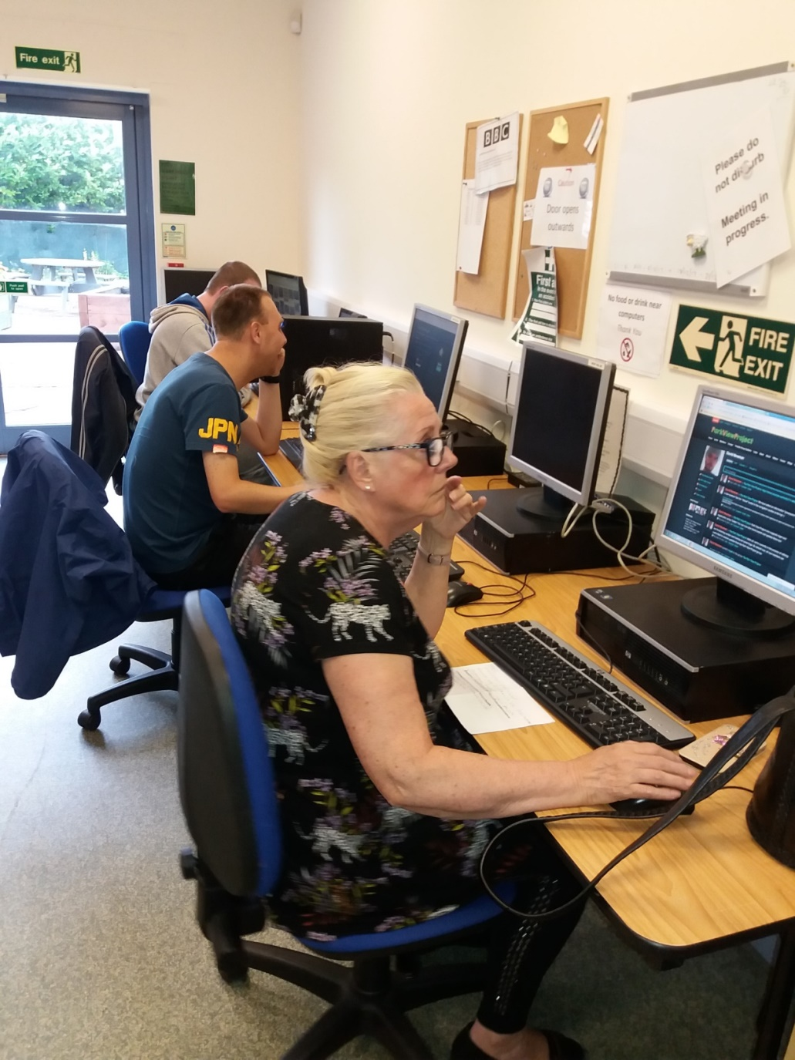
From back to front: Simon, Mart and Vicki Peacock.

